**Challenge-1 (Three tier architecture) - SAGAR MENDIRATTA**

**What is Three tier architecture?**

Three tier architecture is mainly around three different layers

* Presentation Layer such as Web browsers
* Application Layer such as Amazon EC2, Amazon EKS and Amazon Elastic beanstalk and
* Data Layer to store your data such as Database.

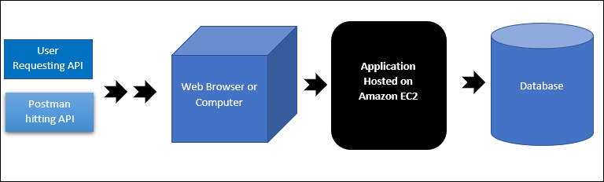

**Aim:** Three tier architecture creation using Terraform which will comprise of **( Code available in Folder)**

* AWS VPC infrastrure
* AWS Service RDS (Postgres) database instance
* Two AWS Elastic Cloud compute (AWS EC2)

**Prerequisites**

1. Terraform installed on Windows or ubuntu machine
2. **Finding AMI which will be used to launch AWS EC2 instances.**

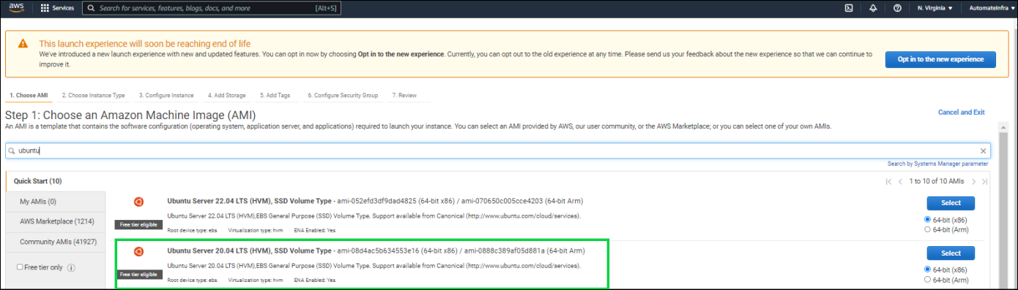

1. Created Wrapper module named 3 Tier which further contains individual modules (VPC, EC2 and RDS)

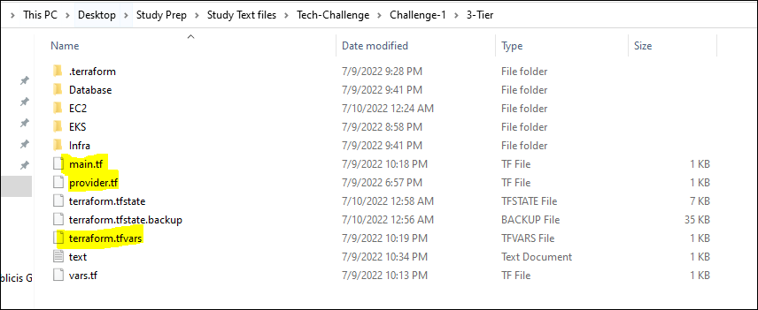

* 1. **VPC Module** creates all the components such as subnets, NAT Gateway, Internet Gateway etc.
  2. **EC2 Module** launches 2 instances using for_each loop. Also, it launches one instance using Provisioner we deploy Apache and find out the metadata of the instance using curl command.
  3. Finally, **RDS modules** creates the secrets first and then using secrets creates the database instance.

**Execution**

1. Executing **terraform init** command

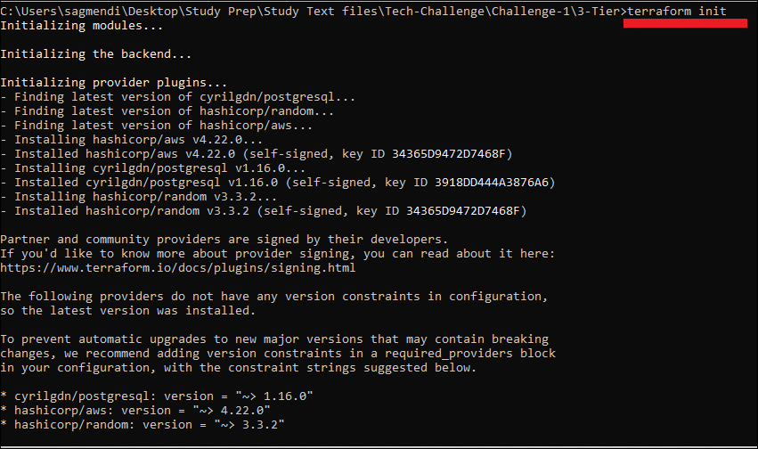

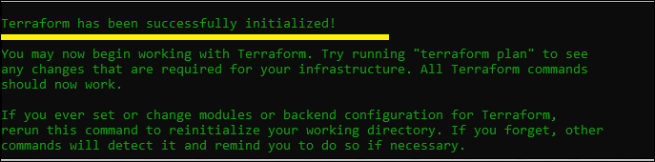

1. Executing **terraform plan** command

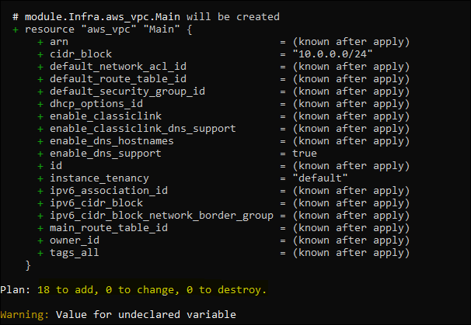

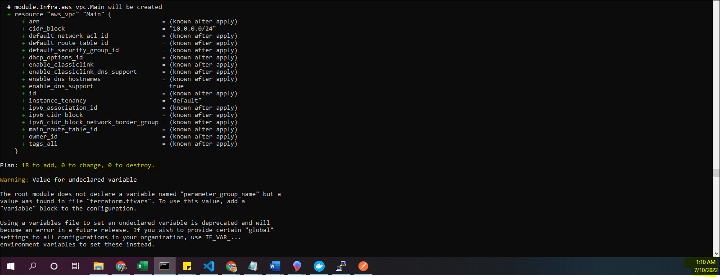

1. Executing **Terraform apply** command

The terraform apply command provisions the below components

* VPC, Route table, public and private subnet, NAT Gateway and IGW
* Deployed two EC2 instance with difference keys
* Deployed one instance with Apache installed
* Used Terraform provisioner to check the instance metadata and

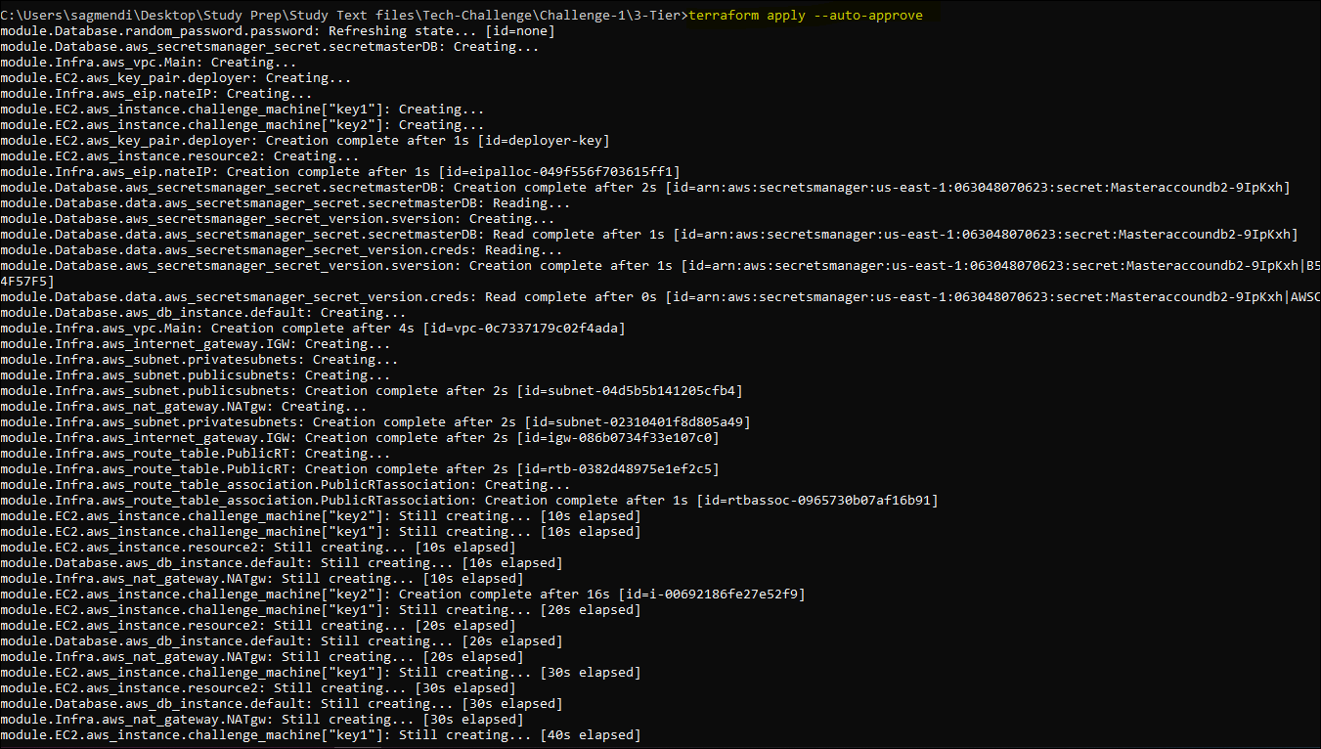

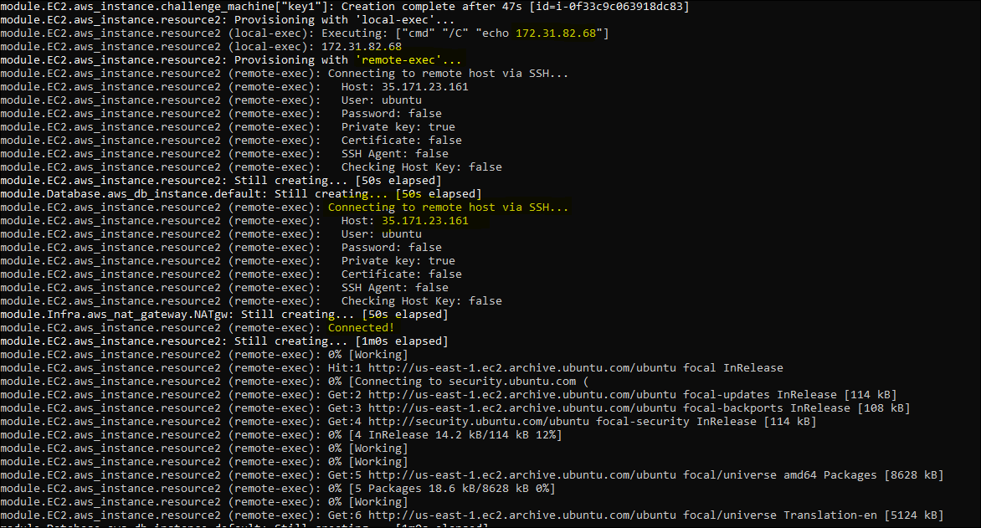

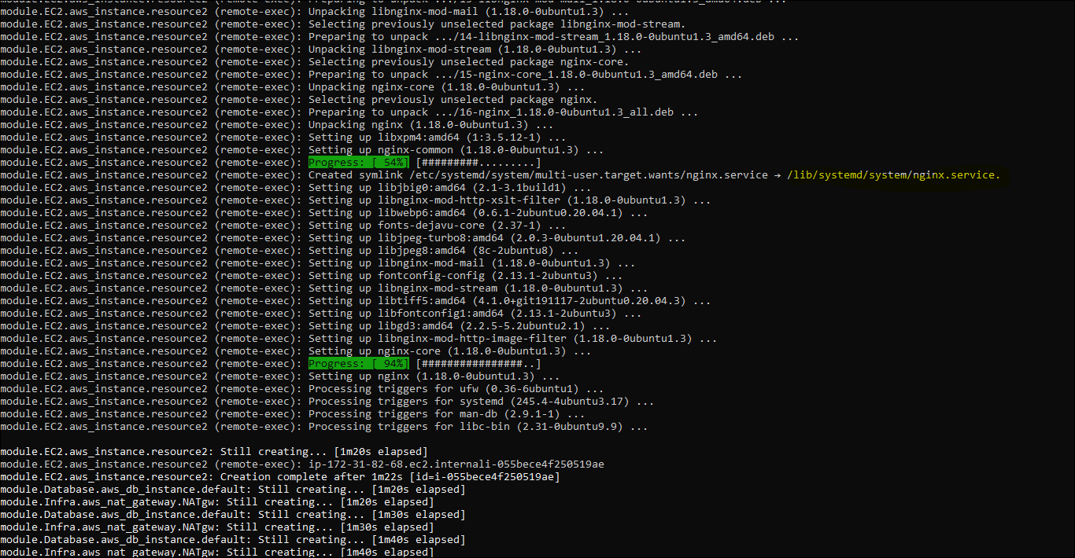

* Using Terraform provisioner

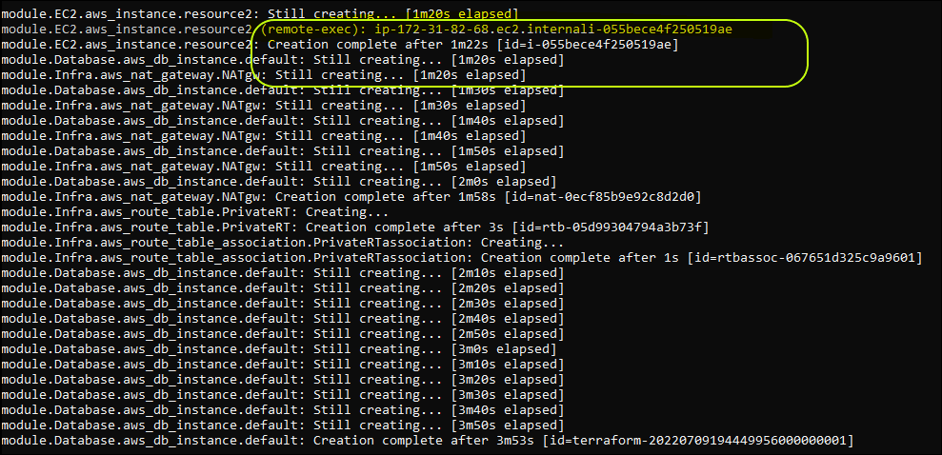

**Verifying AWS Infra, EC2 and RDS database**

* **Database verification**

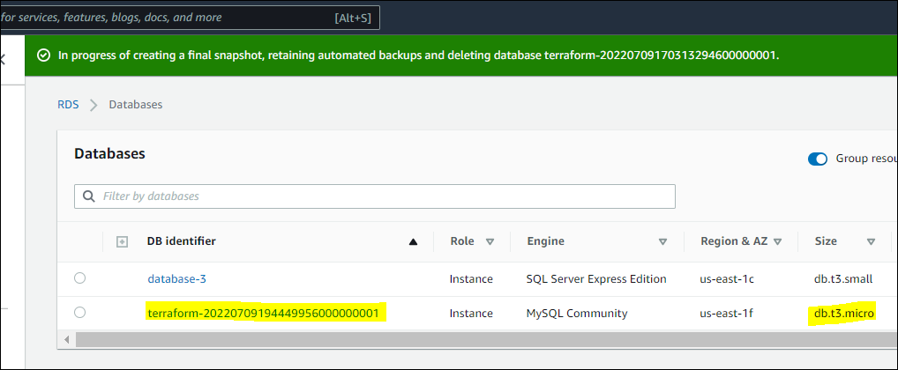

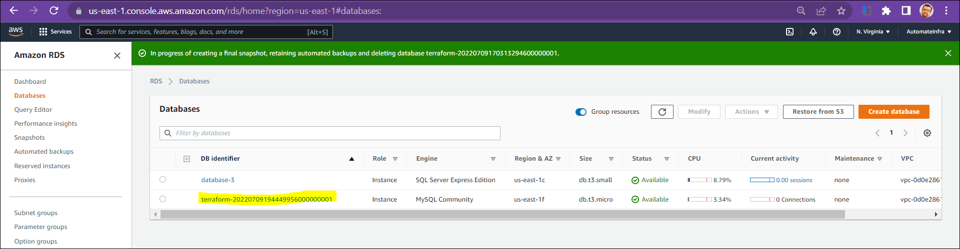

* **VPC verification**

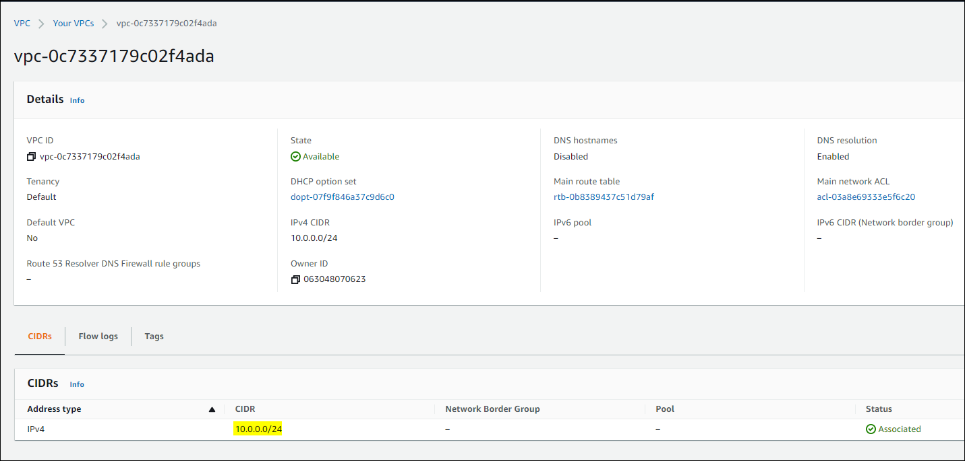

* **EC2 instance verification**

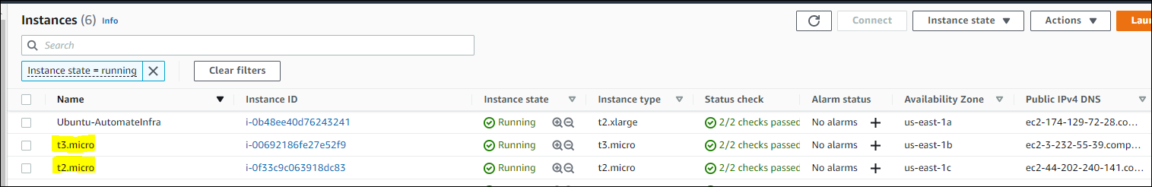

* **Instance with Apache installed and Metadata**

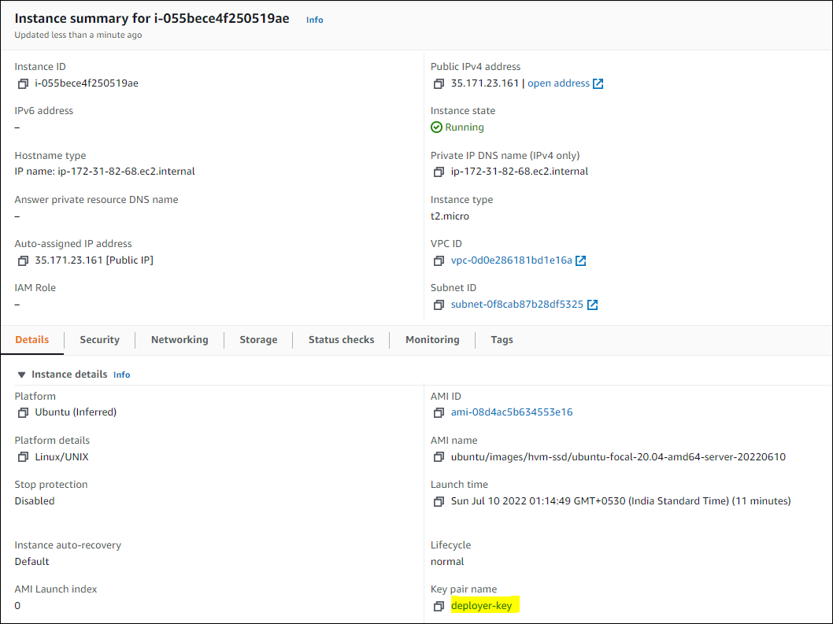

**AWS Secrets**

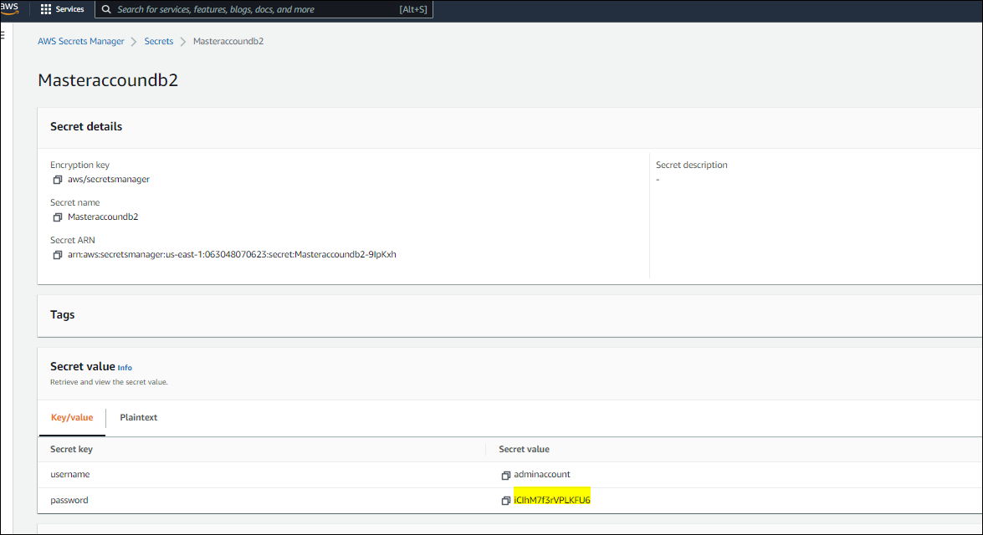



**Testing the 3 tier Layers**

Now that we have successfully provisioned Infra (VPC) and components, RDS and EC2 instance (Apache installed). Let’s test it using **Postman and Python code**.

* On web Browser checking the Apache instance launched using Terraform.

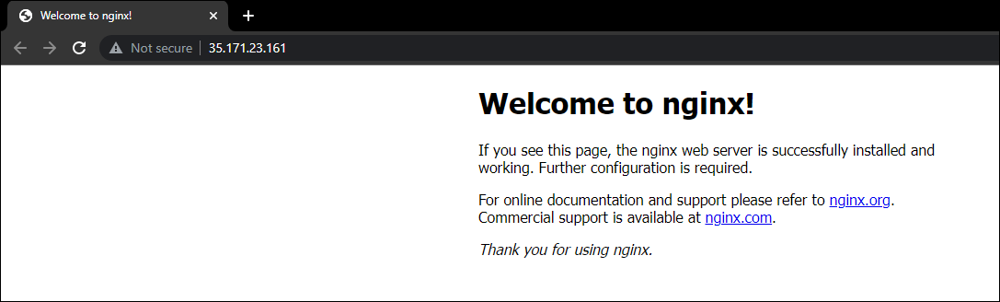

* Using postman to get the response of the Apache API

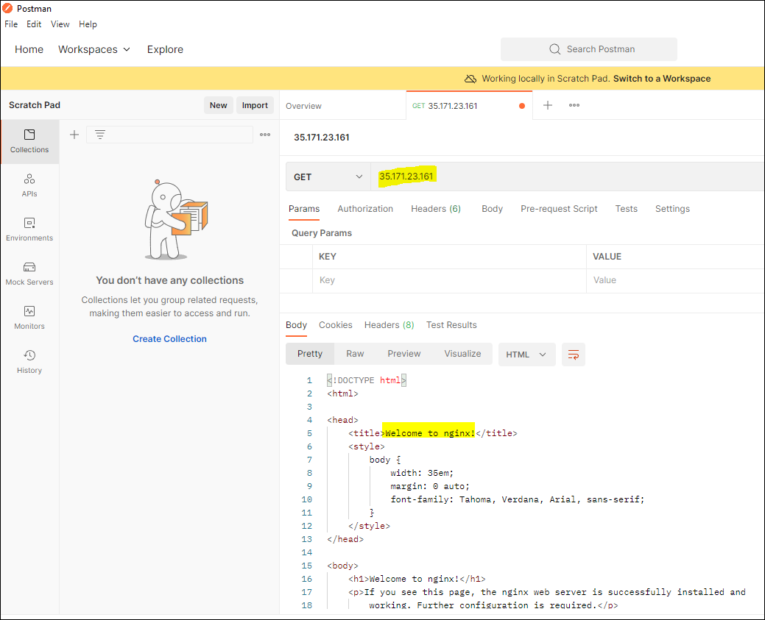

* Using Python code to get the response of the Apache API

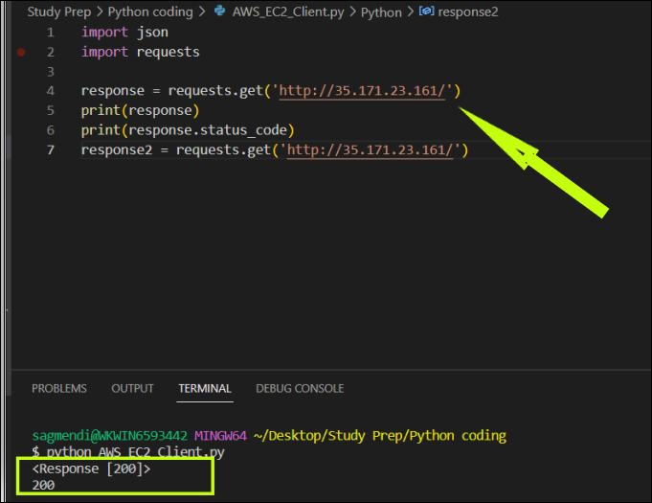

* **On AWS EC2 instance, executed Python code to retrieve AWS Secrets and connect to MYSQL database. (Code available in Folder)**

